LAB ACTIVITY 1:

Introduction to Basic Operations in Python

**Learning Outcomes:**

By the end of this laboratory session, you should be able to:

1. Display the use of different types of literal.
2. Display the implementation of Python operators.

**Hardware/Software:** Computer, Phyton 3.5 or above.

**Activity 1A(i)**

Activity Outcome**:** Display the use of different types of literal in phyton.

Procedure:

**Step 1:** Open Code editor and type the following code:

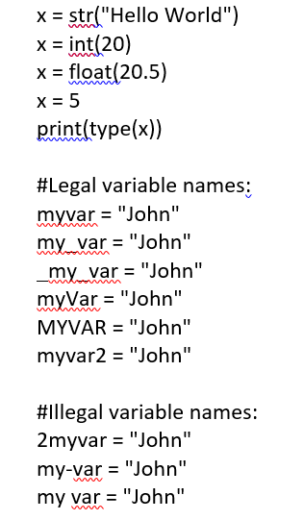

**Step 2:** Save, compile and run the program. Save the program as Act1A.py. Write the output in the area below.

**Output:**

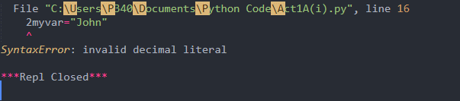

**Activity 1A(ii)**

Activity Outcome**:** Display the use of different types of literal in phyton

Procedure:

**Step 1:** Open Code editor and type the following code:

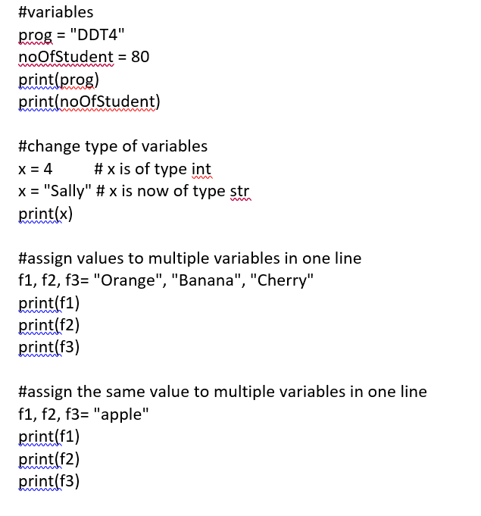

print(type(prog))

**Step 2:** Save, compile and run the program. Save the program as Act1A.py. Write the output in the area below.

**Output:**

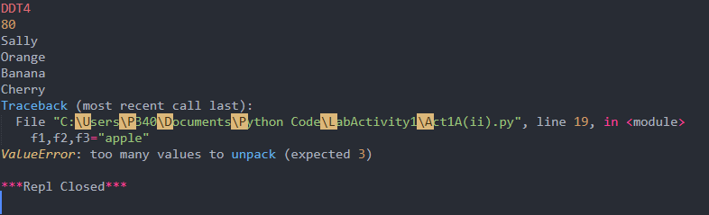

**Activity 1B**

Activity Outcome: Arithmetic Operators

**Activity 1B**

Activity Outcome: Arithmetic Operators

Procedure:

**Step 1:** Open code editor and type the following code:

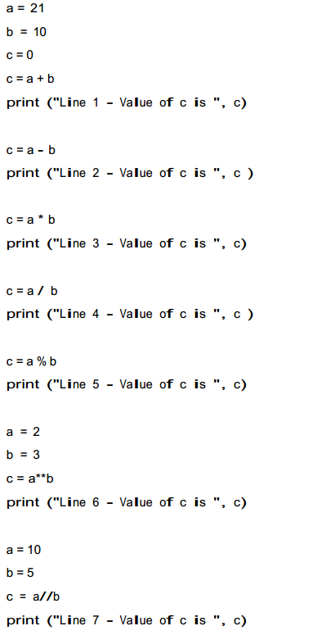

**Procedure:**

**Step 2:** Save, compile and run the program. Save the program as Act1B.py. Write the output in the area below.

**Output:**

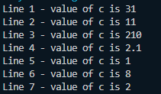

**Activity 1C**

Activity Outcome : Expressions and Operator Precedence.

Procedures:

**Step 1:** Open code editor and type the following code:

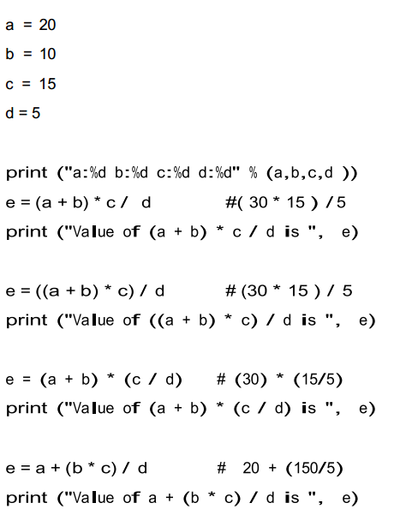s

**Step 2:**  Save, compile and run the program. Save the program as Act1C.py. Observe the output.

**Output:**

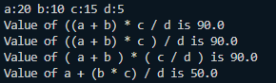

**Activity 1D**

Activity Outcome : Assignment Operators

Procedures:

**Step 1:** Open code editor and type the following code:

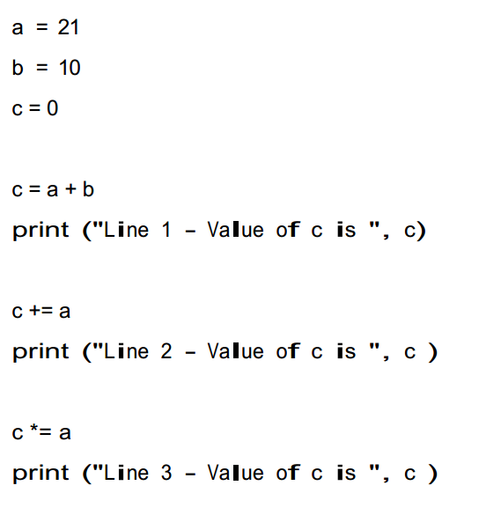

**Step 2:**  Save, compile and run the program. Save the program as Act1D.py. Observe the output.

**Output:**

